Section 18: Containers on AWS: ECS, Fargate, ECR, & EKS

AWS Solution Architect Associate

# 193. Docker Introduction

# 194. ECS Overview

ExamTip:

If you have a ECS service with task that need to access a specific AWS service 🡪 create your own ECS task roles.

# 195. ECS Services & Tasks, Load Balancing

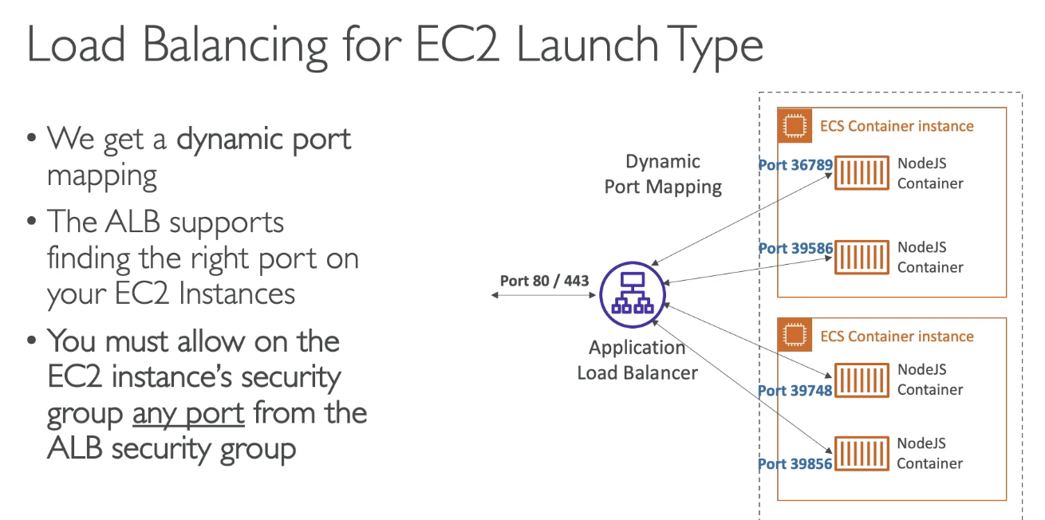

# 197. ECS Scaling

## CPU Usage

## SQS Queue

# 198. ECS Rolling Updates

* Min Healthy Percent – you are allowed to terminate all the version1 tasks in the R.H.S, as long as the capacity meets the min healthy percent
* Max Healthy Percent – How many new tasks you can create of the version2, to basically roll update your service.

# 199. ECR Overview

It is a very light topic in the exam

# 200. EKS Overview

Remember:

* EKS is for Kunernetes
* EKS is cloud-agnostic

